Parking Management System

In this project we designed two users such as Admin & Resident

1. Admin: admin can login to application by using static database login details like admin and admin and later can change profile. Admin can add resident details, add vehicle details, add parking slots and can perform delete, view and update operations for each module. Can view complaints and can collect monthly wise parking fee. If resident paid for current month then he can view status as ‘Payment Done’ else admin can collect payment. Admin can add parking for Resident or guest user and once guest user exit then he can delete slot. Admin can change status to Current or Past Resident.
2. Resident: Resident can login by using his ID given by admin and later resident can update his profile. Add or update or delete new vehicles and can make payment and generate complaints.

Below is the database design for this application

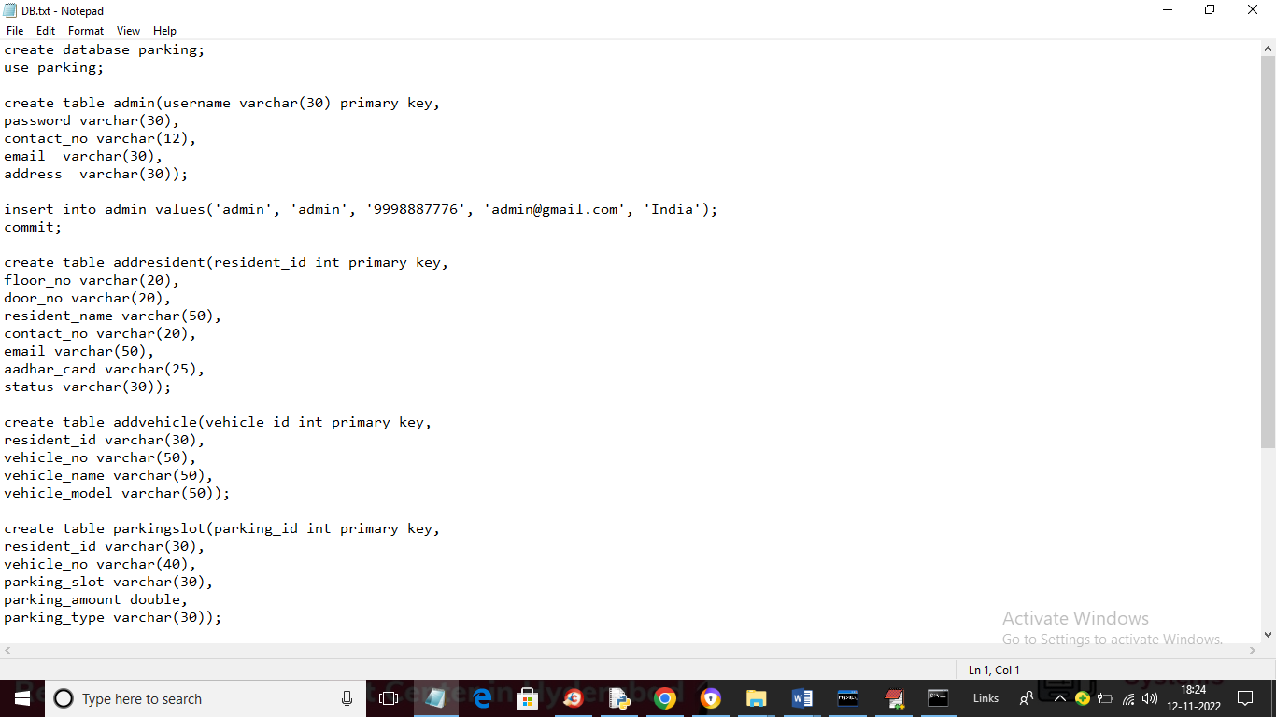

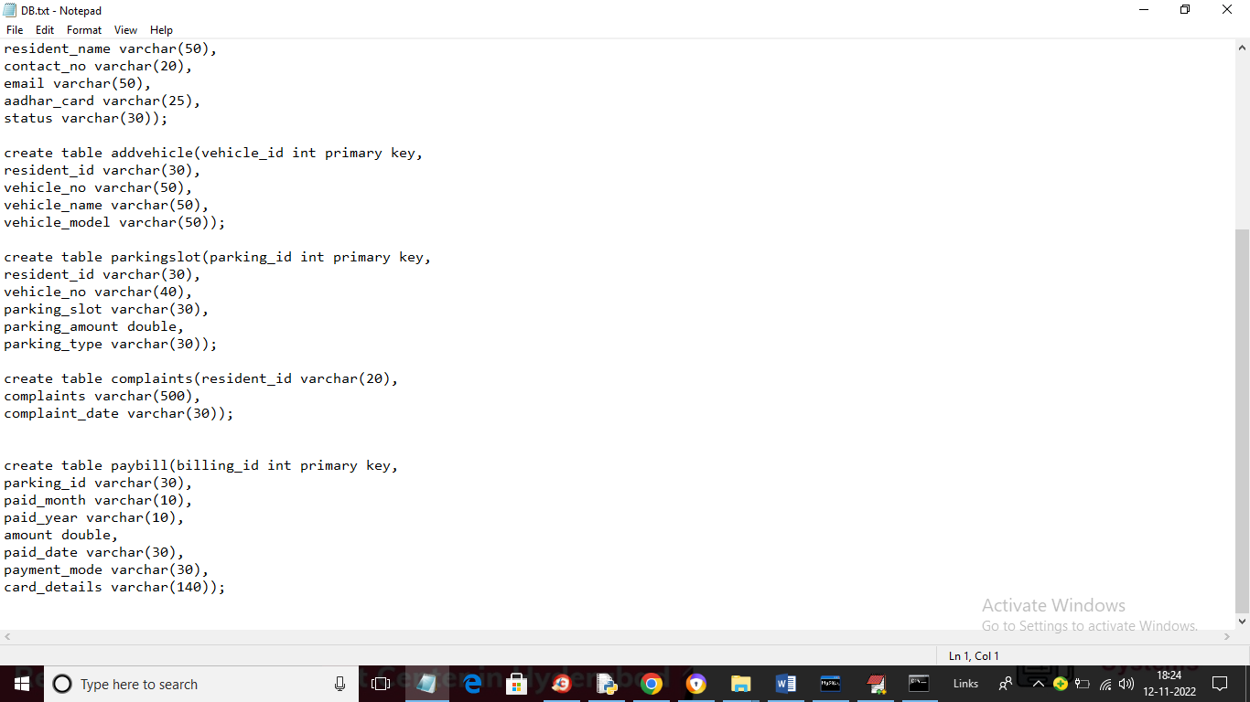

Now copy above database tables from ‘DB.txt’ and paste in MYSQL console o create database.

SCREEN SHOTS

To run project double click on ‘run.bat’ file to start FLASK server and get below screen

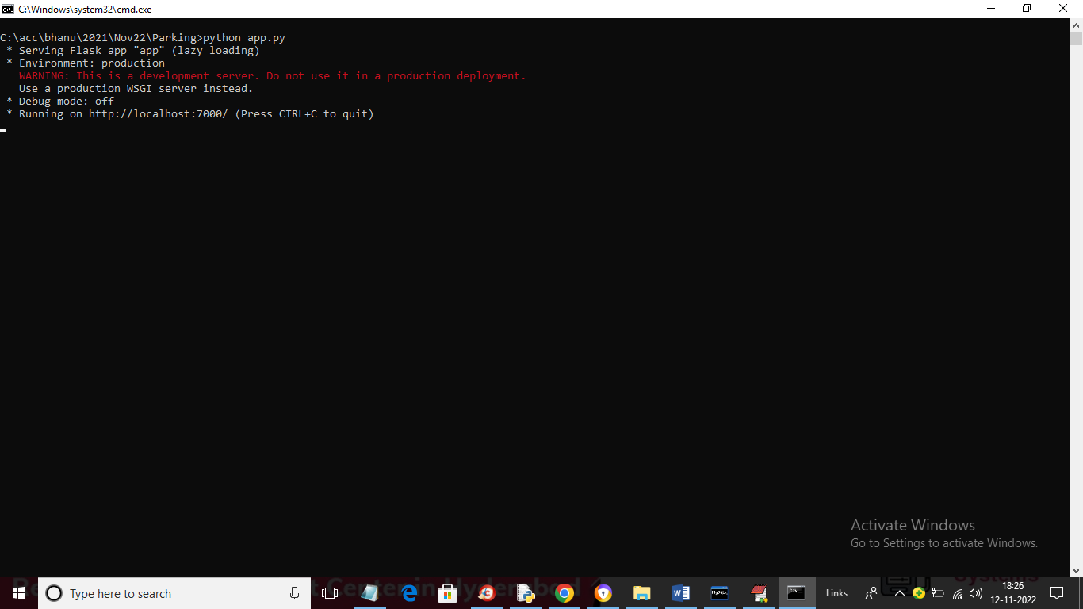

In above screen FLASK server started and now open browser and enter URL as <http://127.0.0.1:7000/index> and press enter key to get below home page

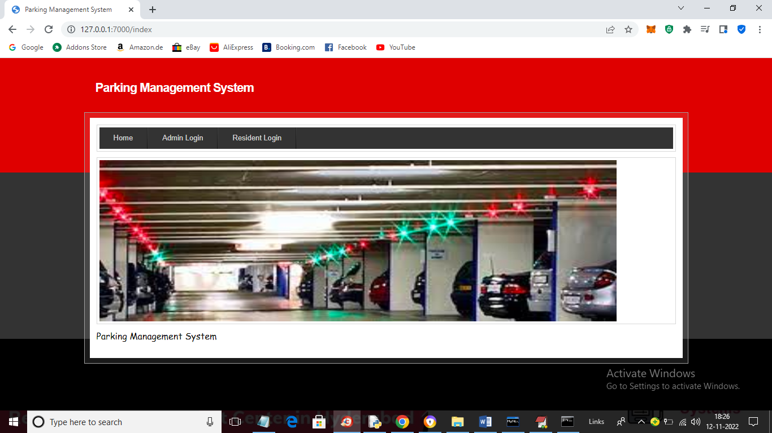

In above screen click on ‘Admin Login’ link to get below login page

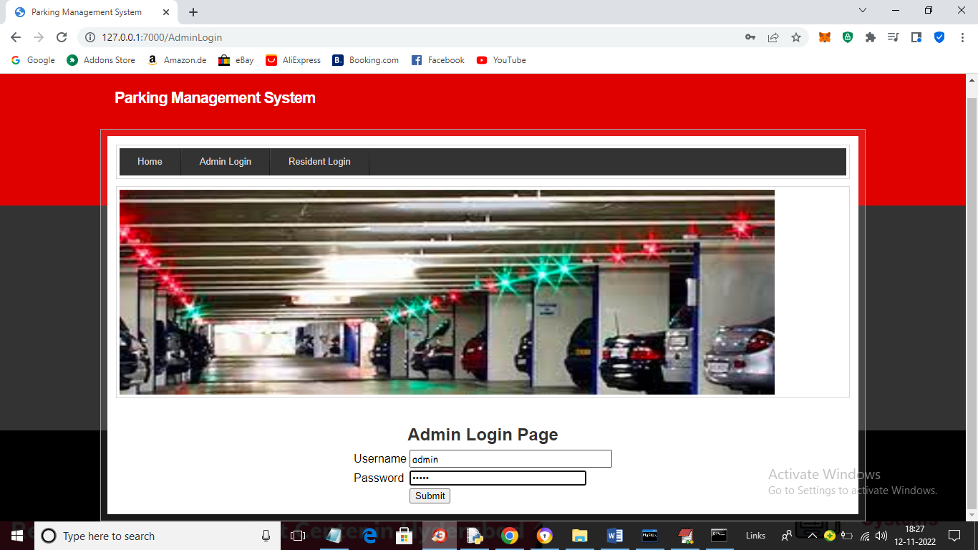

In above screen admin in login and after login will get below page

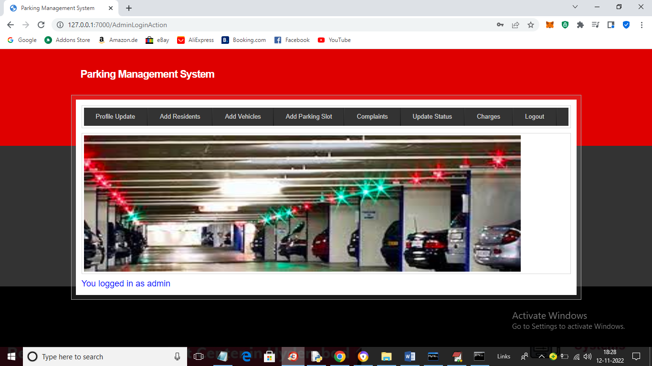

In above screen admin can click on ‘Profile Update’ link to get below profile page

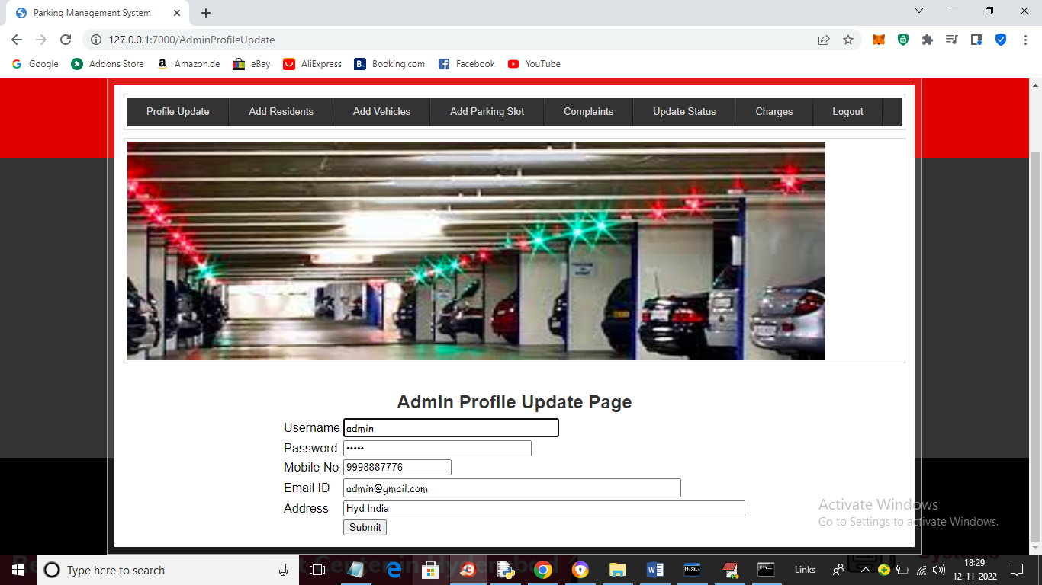

In above screen except username admin can change any details and then press button to update details and get below output

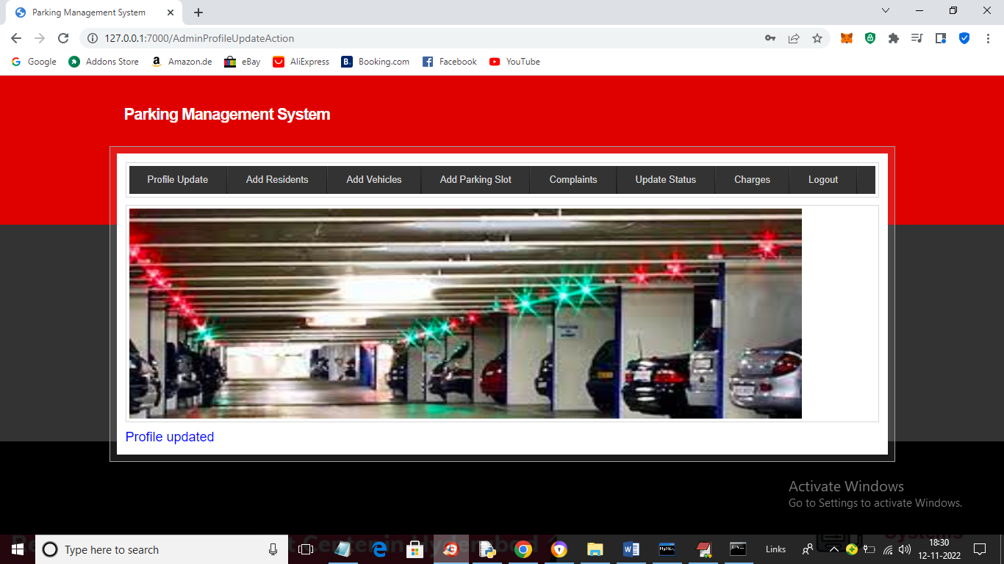

In above screen in blue colour text we can see profile updated and now click on ‘Add Residents’ link to get below page

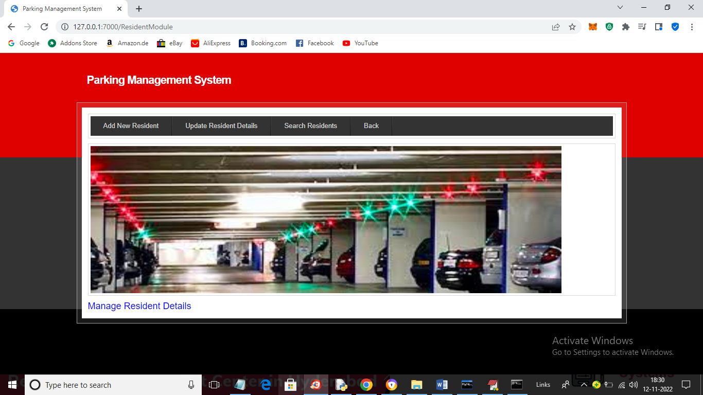

In above screen click on ‘Add New Residents’ link to get below page

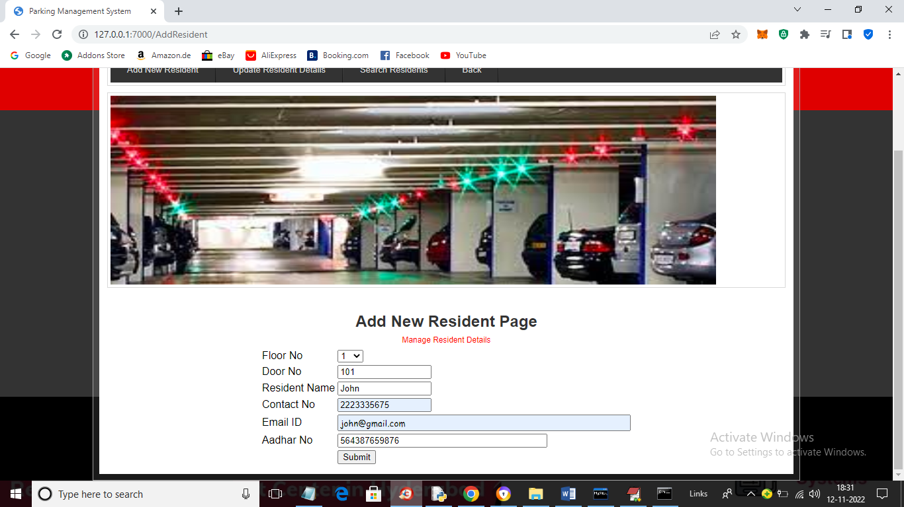

In above screen admin will add all resident details like floor no, door no and other details and then press button to get below output

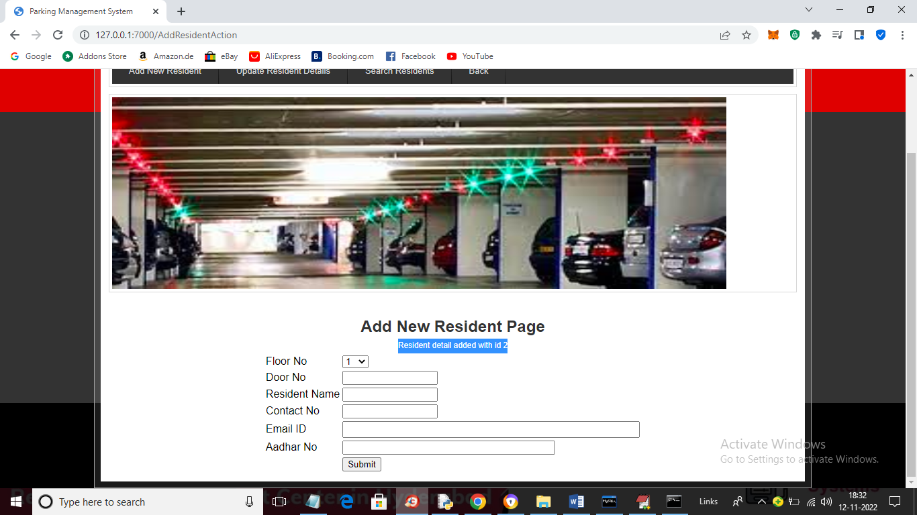

In above screen in blue colour text we can see Resident details added and now click on ‘Update Residents Details’ link to get below page

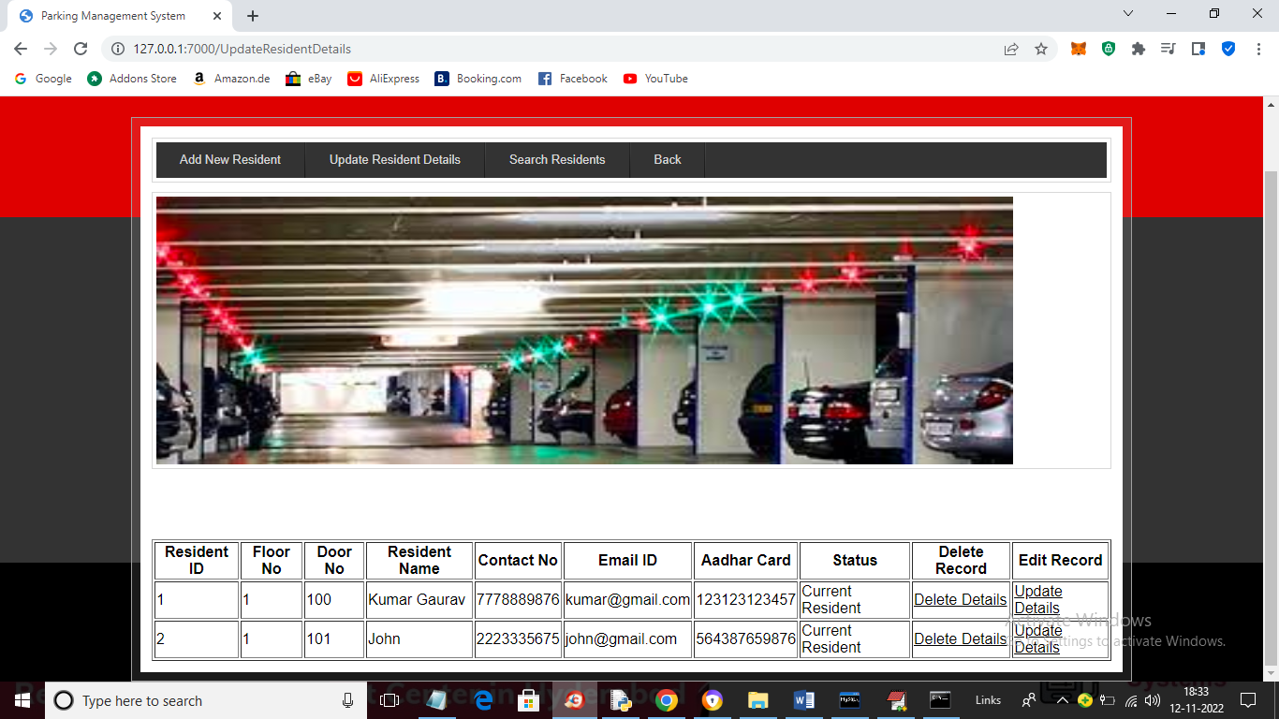

In above screen admin can view list of all residents and then click on either Delete or Update link to delete or update resident details and now click on ‘Search Residents’ link to get below page

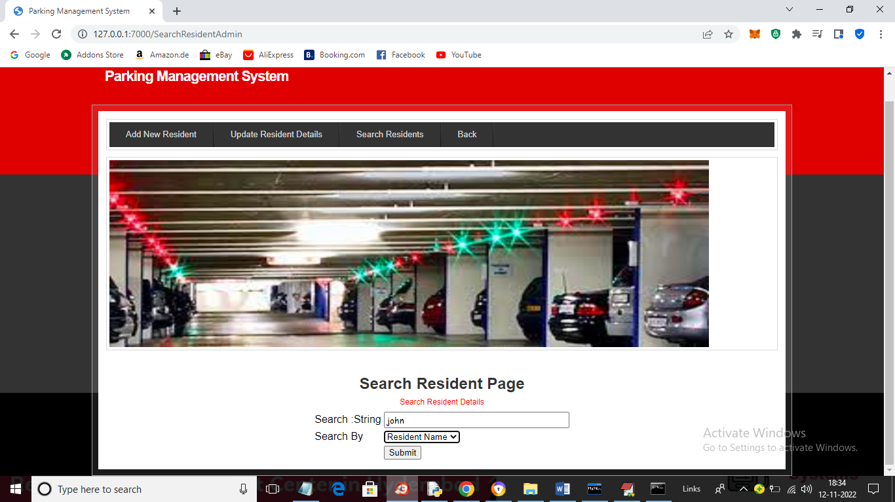

In above screen admin can search residents by using their phone no or name and then press button to get below output

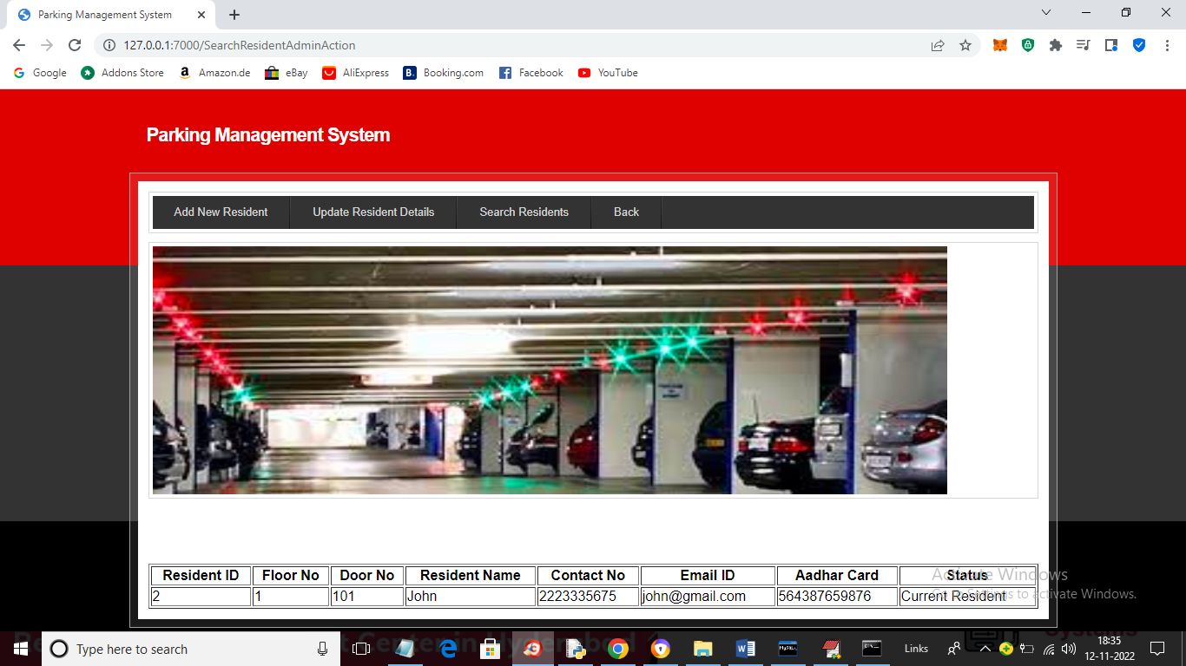

In above screen admin can view searched resident details and now click on ‘Back’ and then click on ‘Add Vehicle Details’ link to get below screen

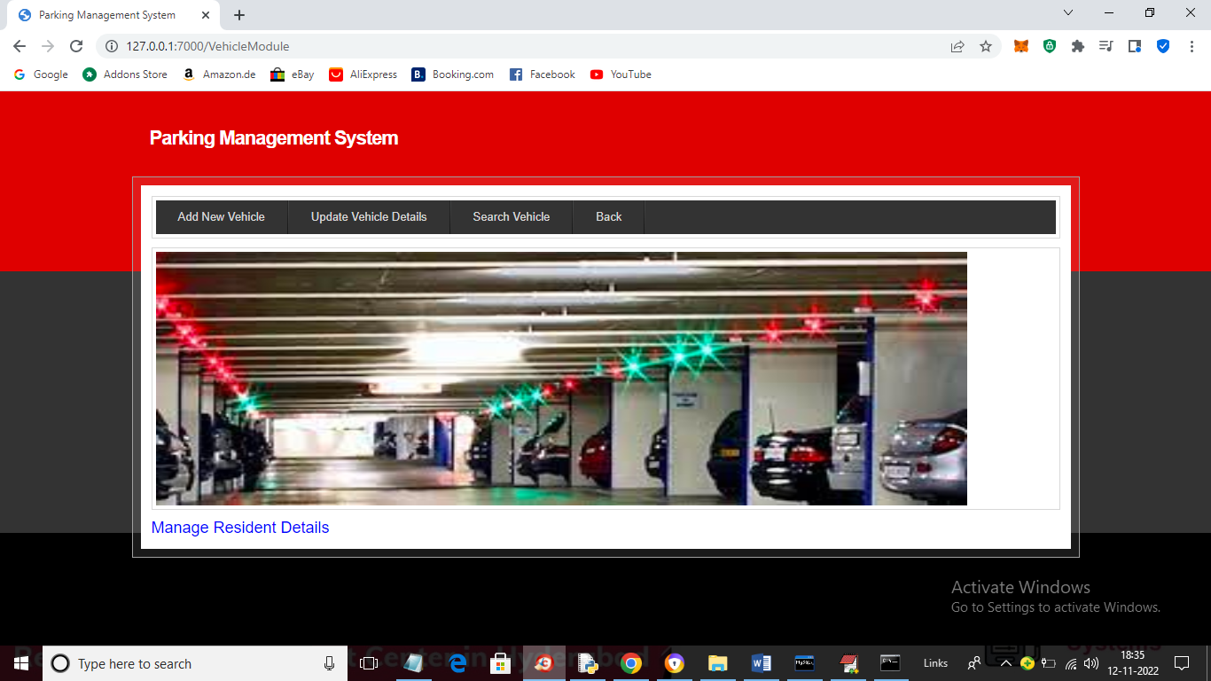

In above screen admin can click on ‘Add Vehicle’ link to get below page

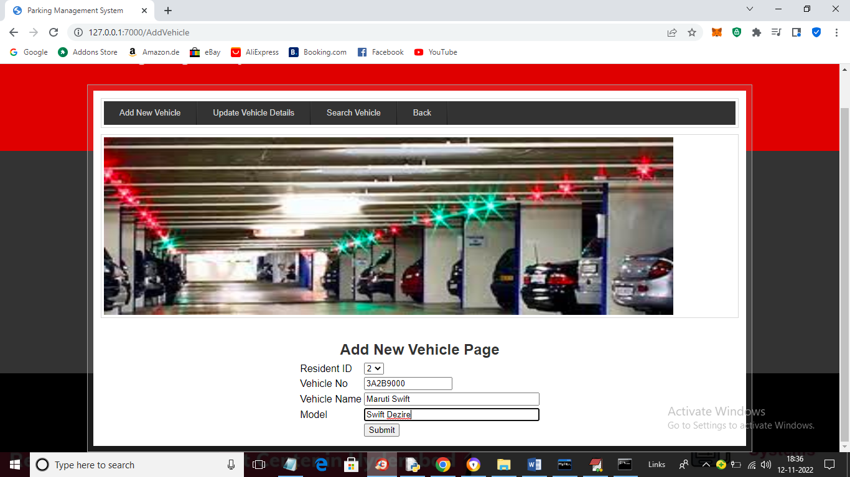

In above screen admin will select Resident ID and then enter his vehicle details and then press button to add vehicle details and get below output

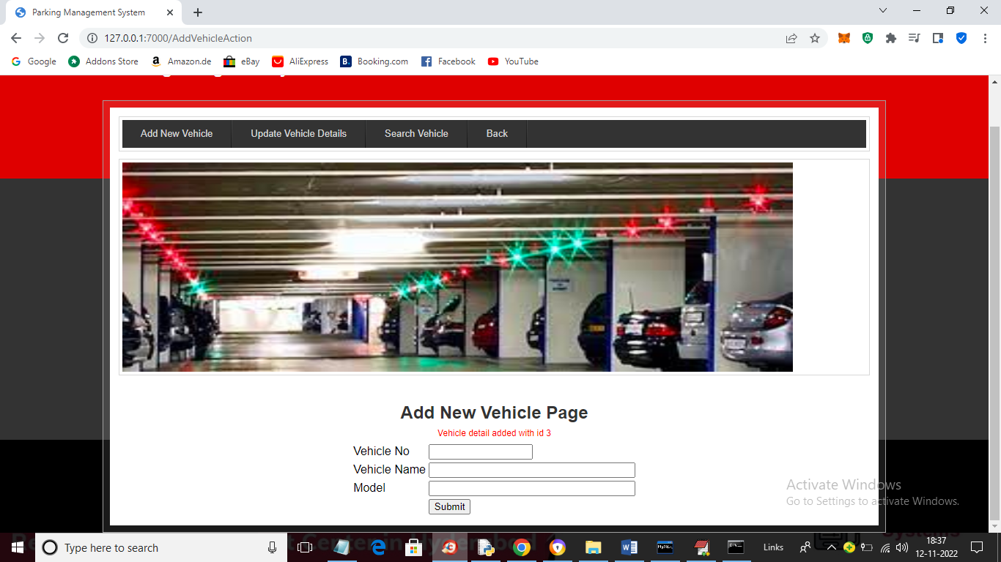

In above screen in red colour text we can see vehicle details added and similarly you can update or delete or search vehicle details and now click on ‘Back’ button to get below page

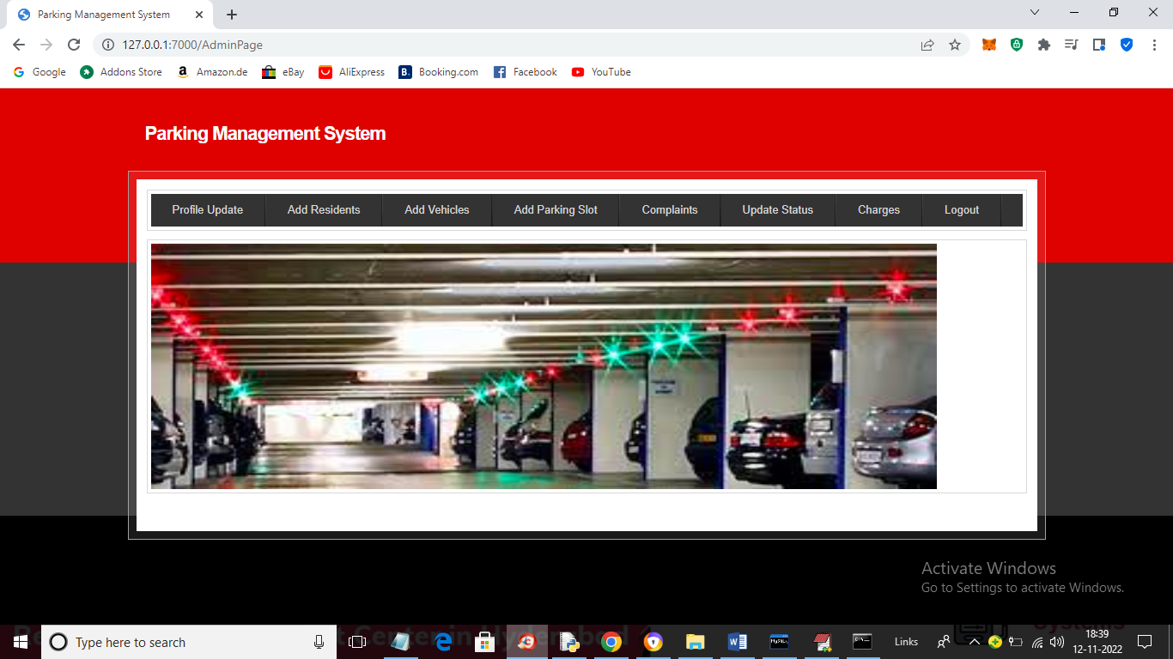

In above screen admin can click on ‘Add Parking Page’ link to add parking details

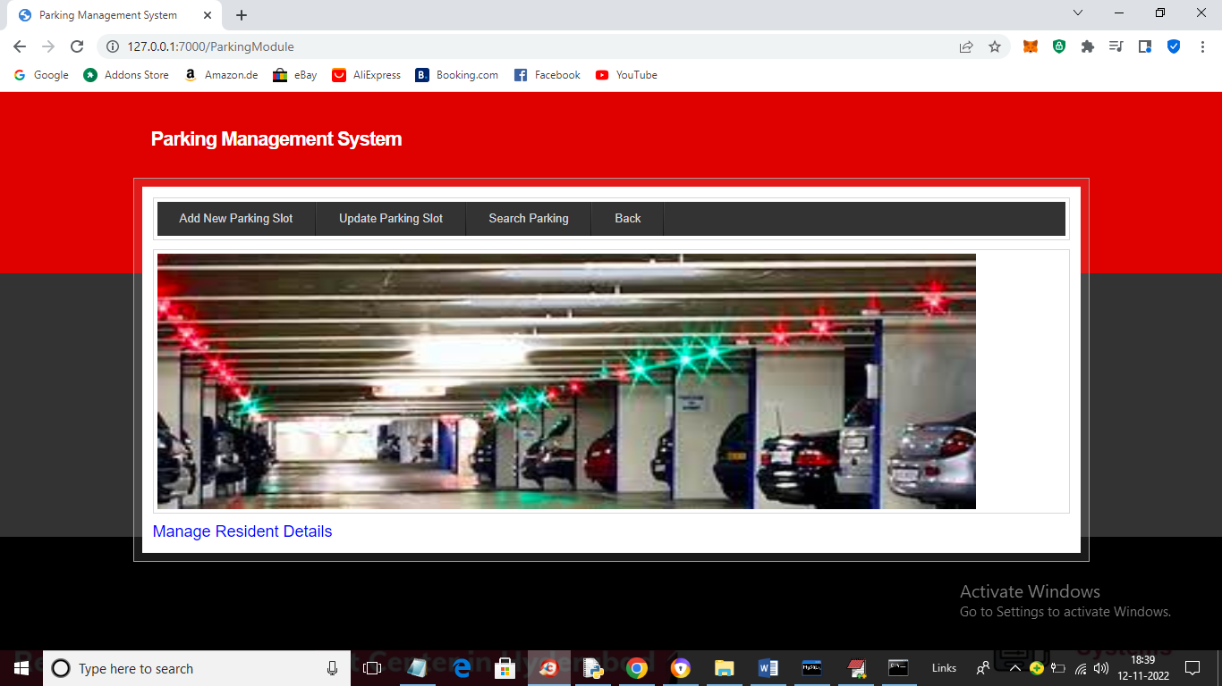

In above screen admin can click on ‘Add New Parking Slot’ link to get below parking details

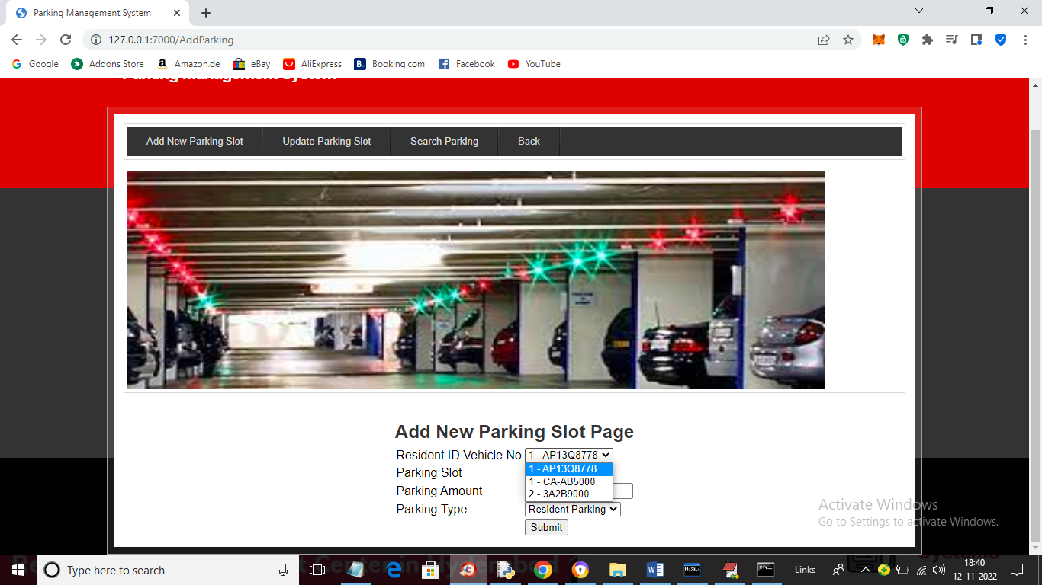

In above screen admin will select Resident ID with vehicle No (as single resident may have multiple vehicles so they are showing separated by ‘-‘ symbol) and then select slot and then enter amount and press button to get below output

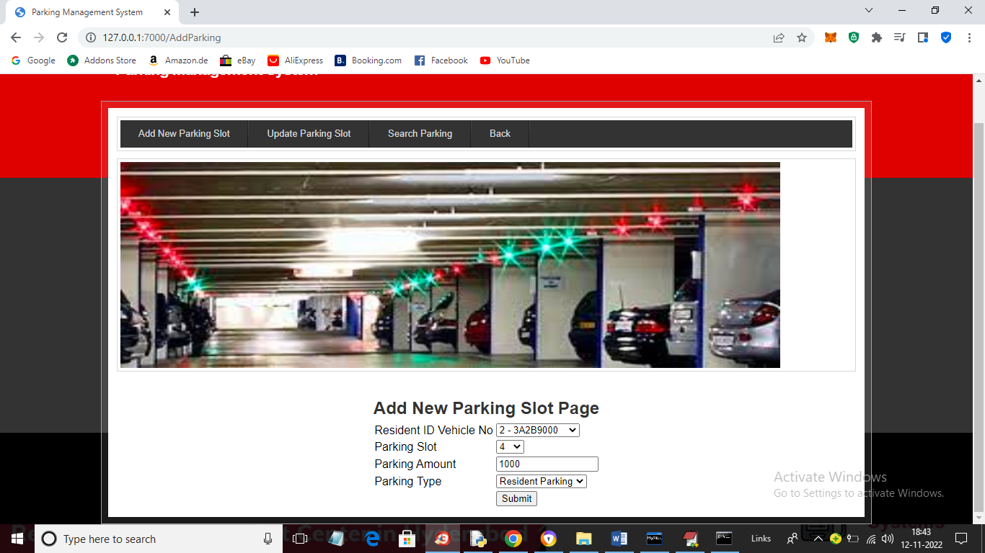

In above screen entered all parking details and then press button to get below page

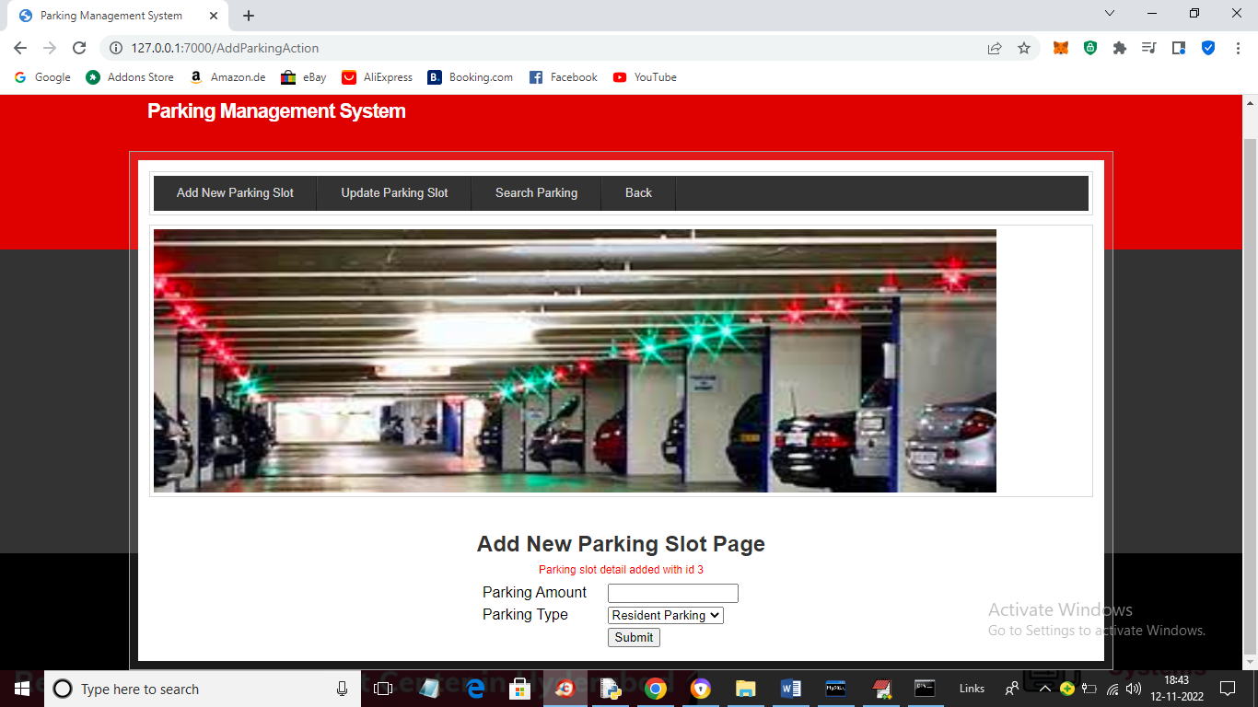

In above screen parking slots details and now delete or update or search details and now click on ‘Back’ link to get below page

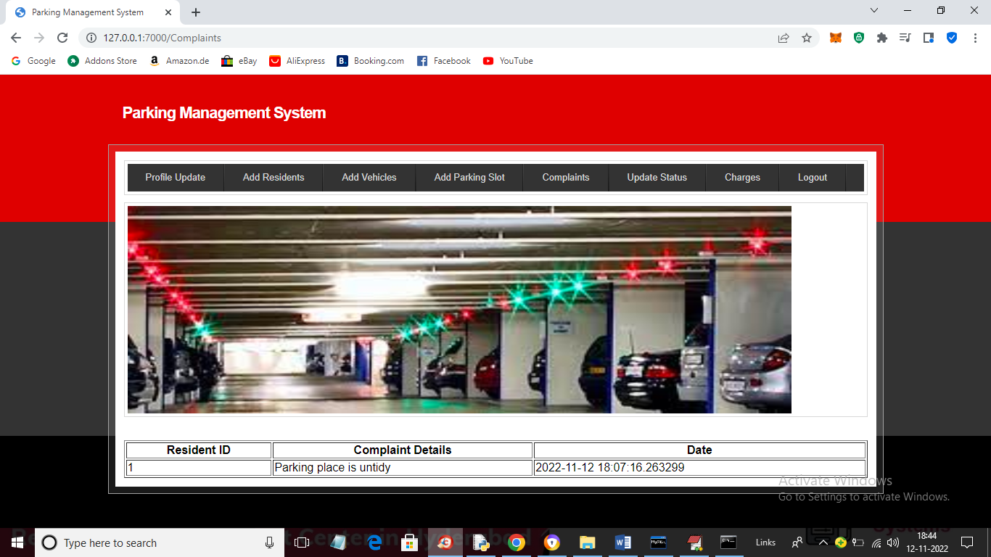

In above screen click on ‘Complaints’ link to view complaints from residents and now click on ‘Update Status’ link to change status and now click on ‘Charges’ link to get below page

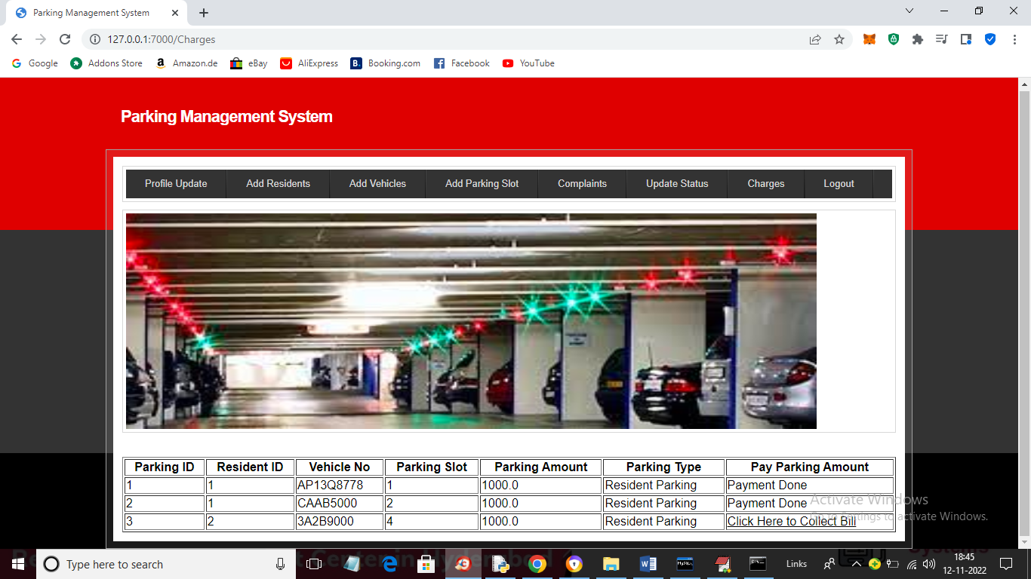

In above screen admin can view list of parking’s with and without payments and then click on ‘Click Here to Collect Bill’ link to collect amount from residents

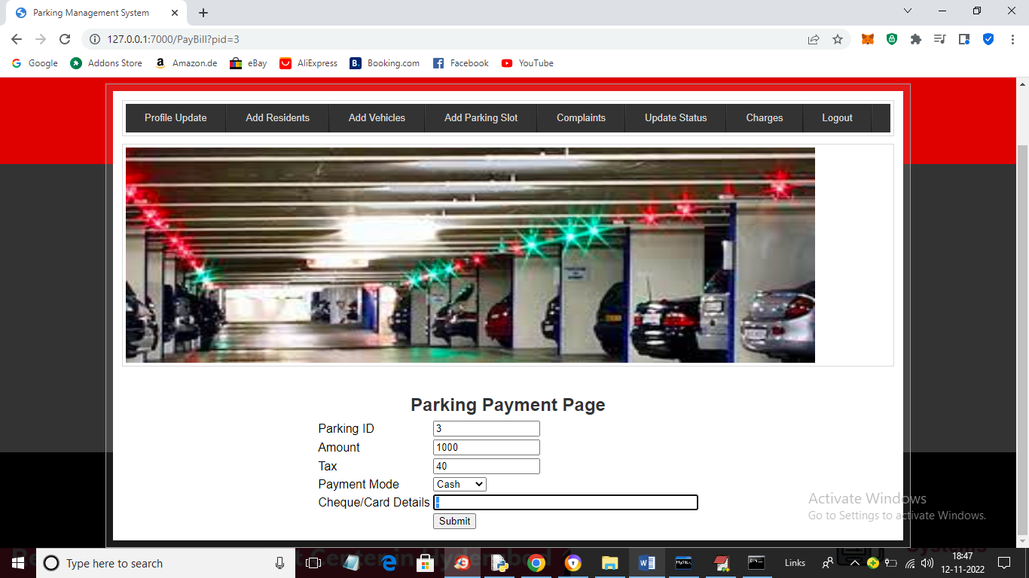

In above screen admin will collect amount and press button to get below receipt

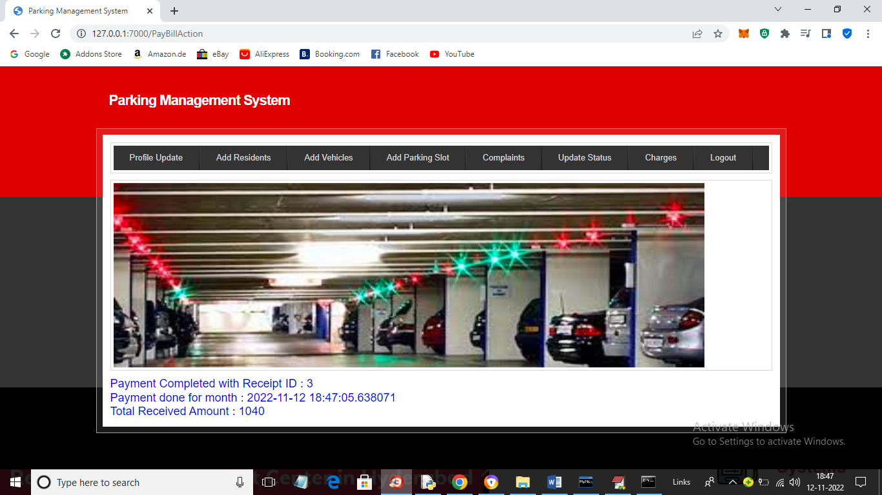

In above screen admin can view receipt generated from payments and now logout and login as resident by using resident ID given by admin

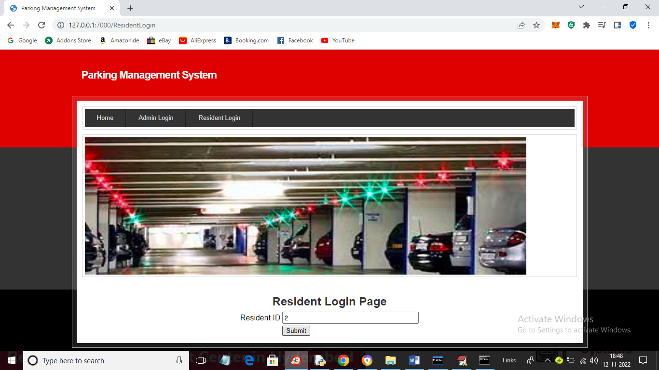

In above screen resident is entering his ID and then press button to get below page

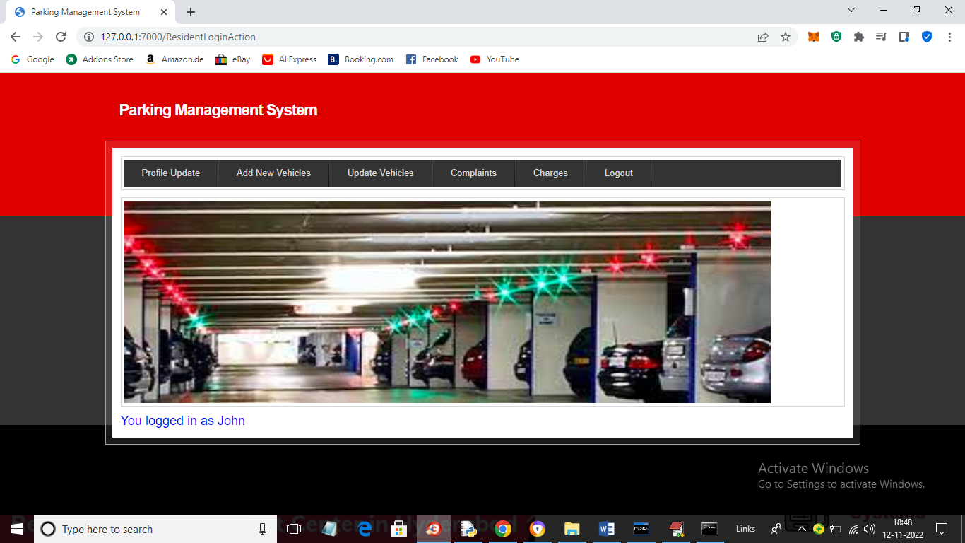

In above screen we can see resident logged in as ‘John’ and now press ‘Profile Update’ link to view profile and update it

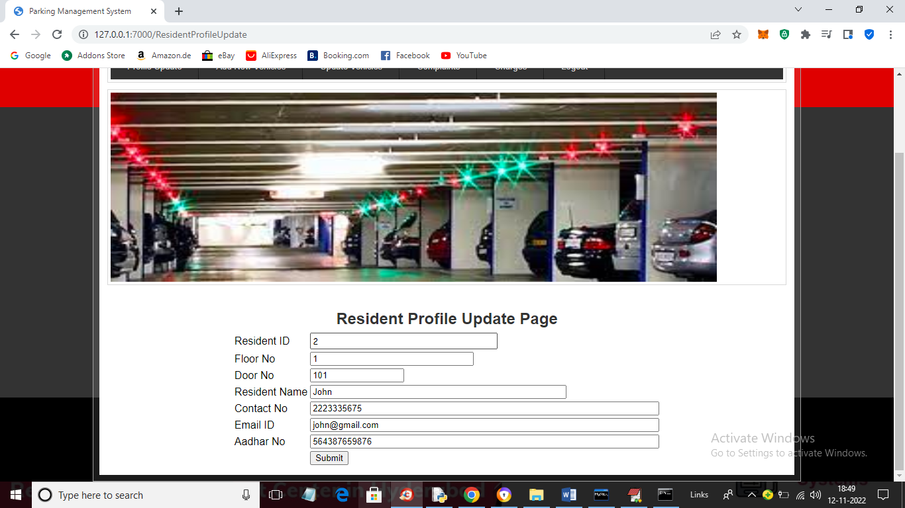

In above screen change any details and press button to update profile and get below output

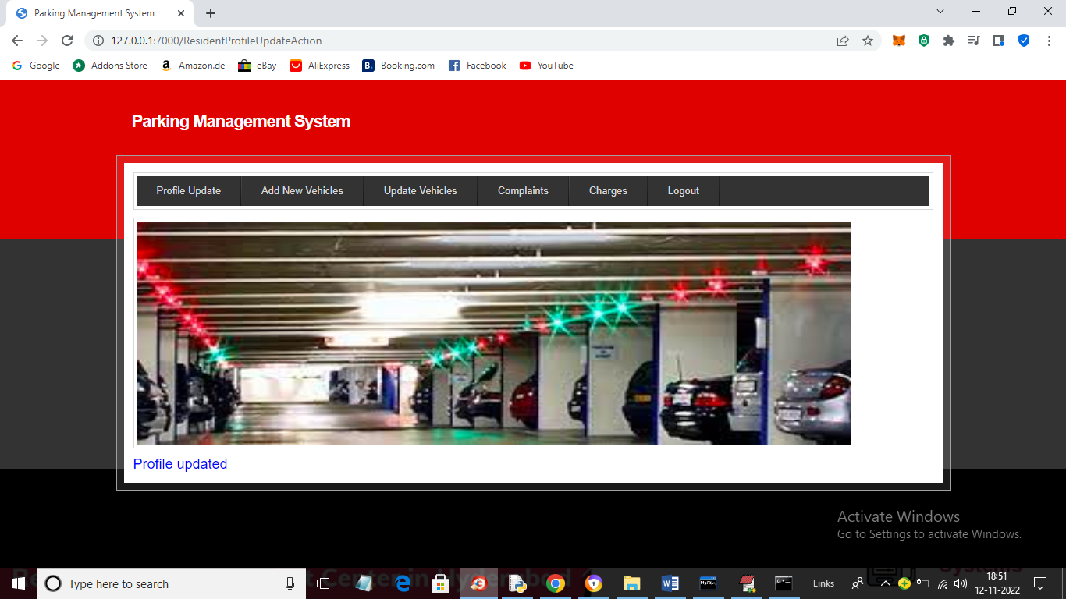

In above screen we can see profile updated and now click on ‘Add New Vehicle’ to allow resident to add his vehicles

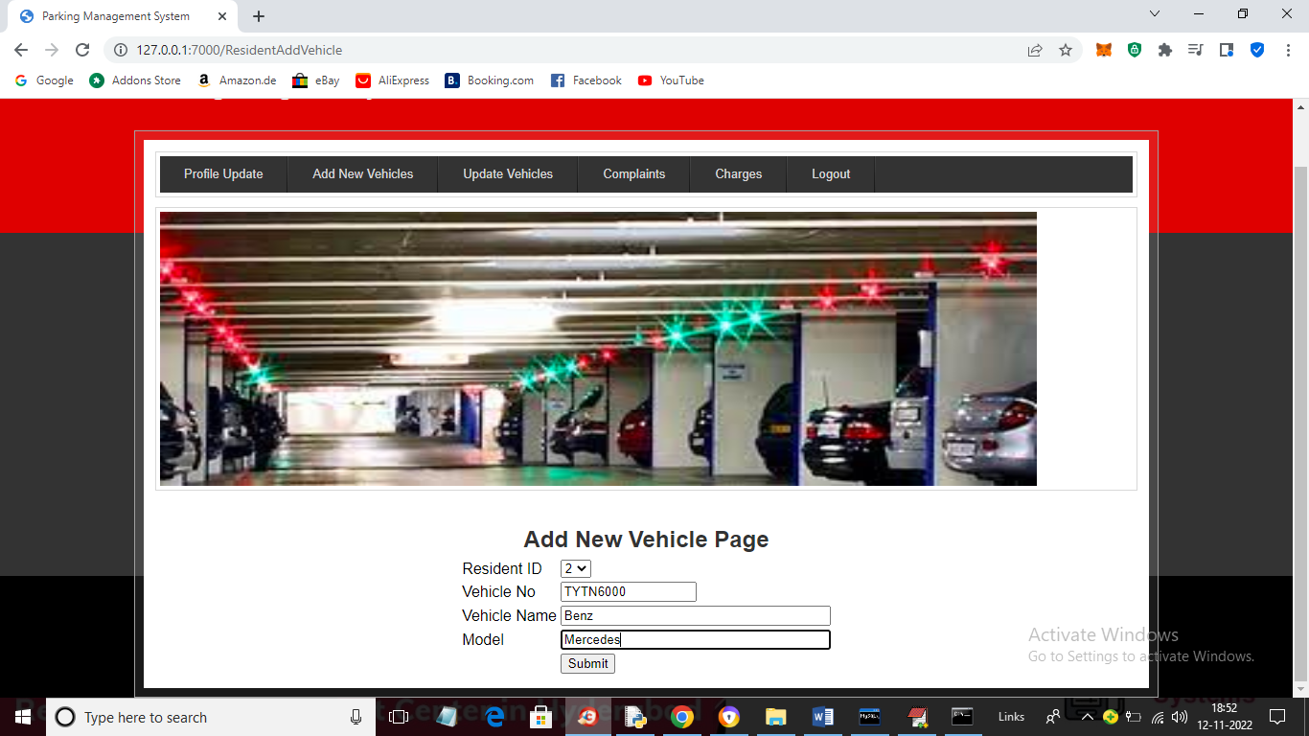

In above screen resident is adding new vehicle and then press button to add details and then admin will allocate slot for it

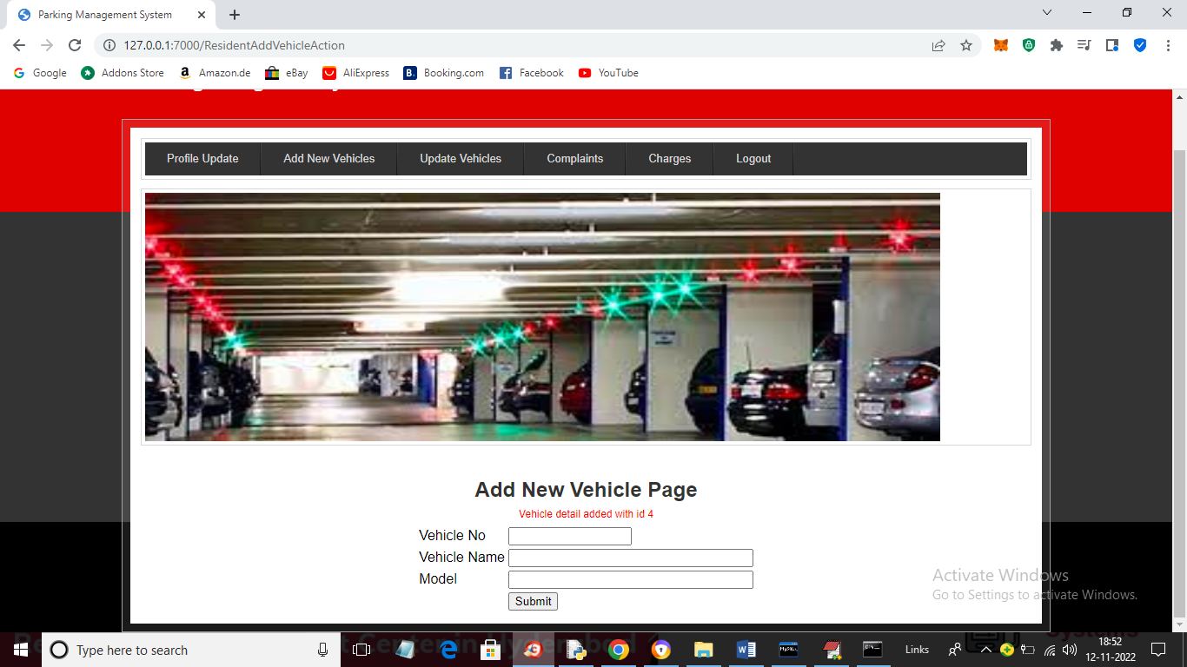

In above screen vehicle details added and now click on ‘Update Vehicles’ link to view, delete and update details

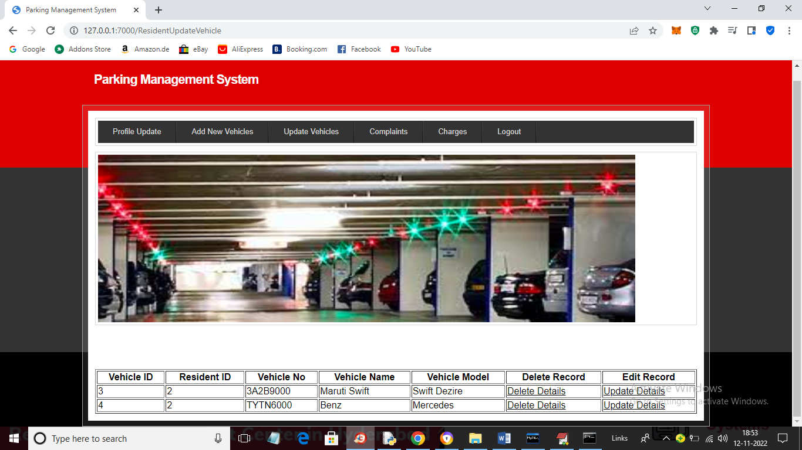

In above screen click on either delete or update button to delete or update vehicle and now click on ‘Complaints’ link to generate complaint

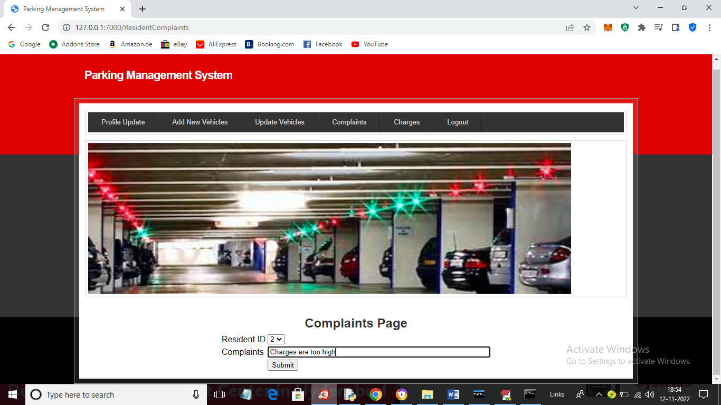

In above screen resident can generate complaint and press button to get below output

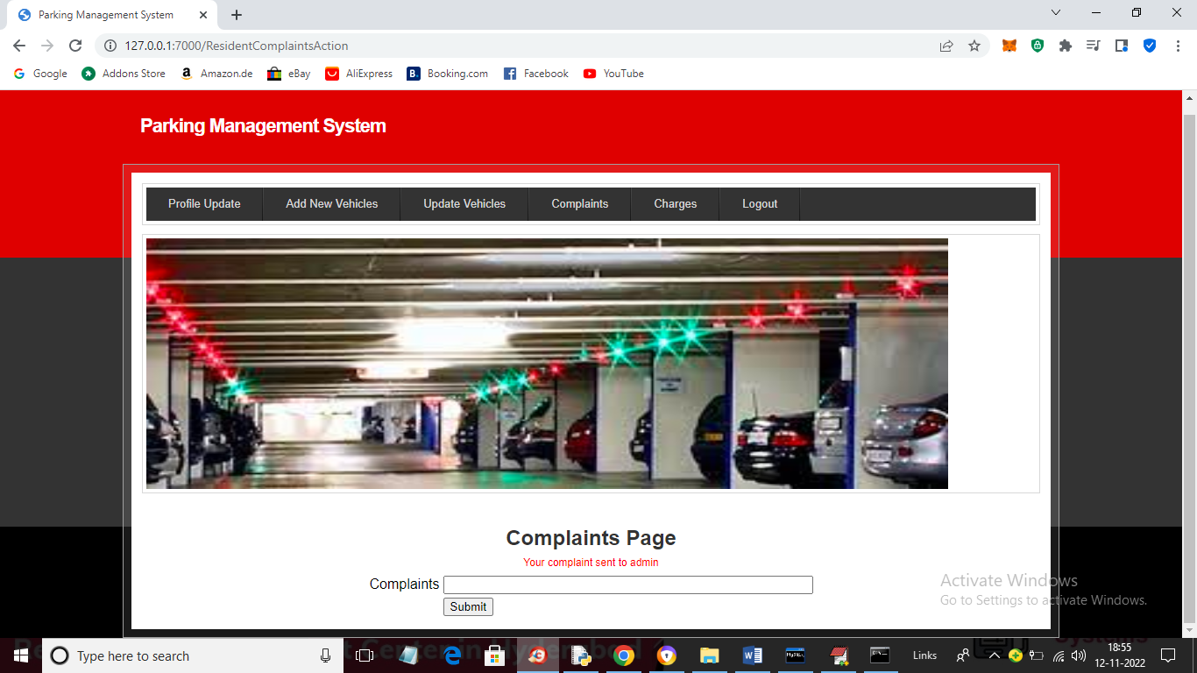

In above screen complaint is sent to admin and now click on ‘Charges’ link to make payment

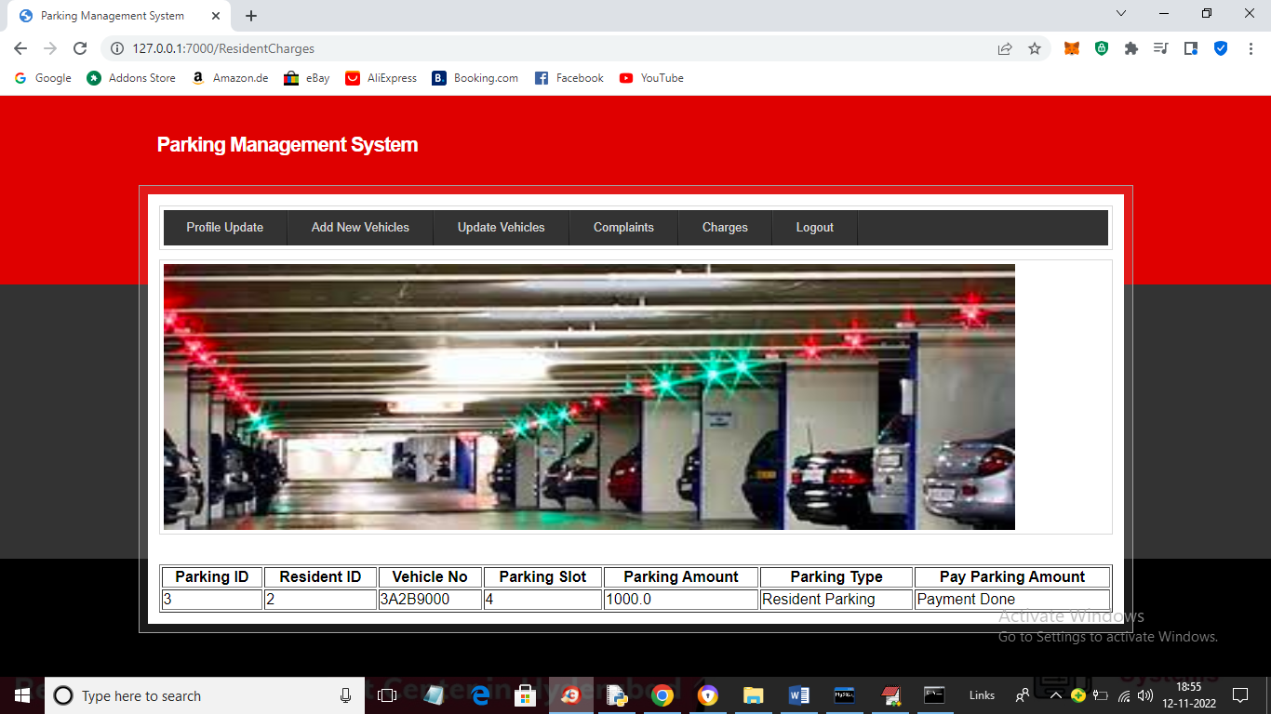

In above screen we can see resident already done payment for current month and if not done then will get link to make payment.

Similarly you can add vehicles and make slot and payments